Fossil-Asia-China-Guizhou, Xingyi-Mid Triassic

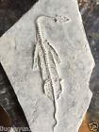

***Keichousaurus*** (key-cho-saurus) is a [genus](https://en.wikipedia.org/wiki/Genus) of marine [reptile](https://en.wikipedia.org/wiki/Reptile) in the [pachypleurosaur](https://en.wikipedia.org/wiki/Pachypleurosaur" \o "Pachypleurosaur) family which went [extinct](https://en.wikipedia.org/wiki/Extinct) at the close of the [Triassic](https://en.wikipedia.org/wiki/Triassic) in the [Triassic-Jurassic extinction event](https://en.wikipedia.org/wiki/Triassic-Jurassic_extinction_event). The name derives from Kweichow (now [Guizhou Province](https://en.wikipedia.org/wiki/Guizhou_Province" \o "Guizhou Province)) in [China](https://en.wikipedia.org/wiki/China) where the first [fossil](https://en.wikipedia.org/wiki/Fossil" \o "Fossil)specimen was discovered in 1957.

|  |
| --- |
| Xingyi is the division at the southwest corner in this map of Qianxinan |
| [Qianxi'nan in Guizhou](https://en.wikipedia.org/wiki/File:Location_of_Qianxinan_Prefecture_within_Guizhou_(China).png)  Qianxi'nan in Guizhou |
| Coordinates: https://upload.wikimedia.org/wikipedia/commons/thumb/5/55/WMA_button2b.png/17px-WMA_button2b.png[25.092°N 104.895°E](https://tools.wmflabs.org/geohack/geohack.php?pagename=Xingyi,_Guizhou&params=25.092_N_104.895_E_type:adm3rd_region:CN-52_source:Gaode) |

They are among the most common [sauropterygian](https://en.wikipedia.org/wiki/Sauropterygian" \o "Sauropterygian) fossils recovered and are often found as nearly complete, articulated skeletons, making them popular among collectors.

*Keichousaurus*, and the pachypleurosaur family broadly, are sometimes classified within [Nothosauroidea](https://en.wikipedia.org/wiki/Nothosauroidea" \o "Nothosauroidea), but are otherwise listed as a separate, more primitive lineage within Sauropterygia.



**Contents**

* [1Description](https://en.wikipedia.org/wiki/Keichousaurus#Description)
* [2Morphology](https://en.wikipedia.org/wiki/Keichousaurus#Morphology)
* [3Locomotion](https://en.wikipedia.org/wiki/Keichousaurus#Locomotion)
* [4Reproduction](https://en.wikipedia.org/wiki/Keichousaurus#Reproduction)
* [5References](https://en.wikipedia.org/wiki/Keichousaurus#References)

Description[[edit](https://en.wikipedia.org/w/index.php?title=Keichousaurus&action=edit&section=1)]

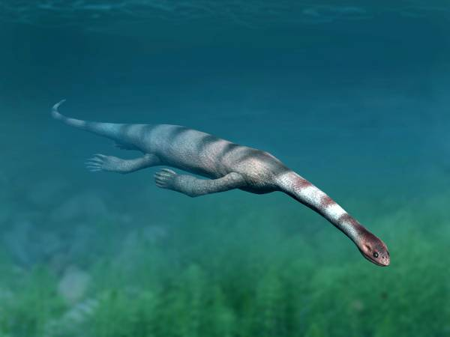

Life restoration of *Keichousaurus hui*

*Keichousaurus*, like all sauropterygians, was highly adapted to the aquatic environment. Individuals of this genus ranged up to 2.7 m in length,[[1]](https://en.wikipedia.org/wiki/Keichousaurus#cite_note-1) and had both long necks and long tails, with elongated, five-toed feet. The pointed head and sharp teeth in this genus also indicate that they were [fish](https://en.wikipedia.org/wiki/Fish)-eaters. Some recovered specimens feature an especially developed [ulna](https://en.wikipedia.org/wiki/Ulna) suggesting they may have spent some time on land or in marshes.

In addition fossil evidence suggest also a pair of fossilized pregnant marine reptiles called *Keichousaurus hui*, show they had a mobile pelvis to give birth to live young rather than laying eggs.

Morphology[[edit](https://en.wikipedia.org/w/index.php?title=Keichousaurus&action=edit&section=2)]

[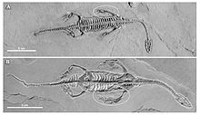](https://en.wikipedia.org/wiki/File:Keichousaurus_hui_sexual_dimorphism.jpg)

Sexual dimorphism

*Keichousaurus hui* was found in 1958 in [Guizhou](https://en.wikipedia.org/wiki/Guizhou" \o "Guizhou), China by palaeontologist [Hu Chengzhi](https://en.wikipedia.org/wiki/Hu_Chengzhi). This fossil is distinguished by its broad ulna which makes it unlike other European genera. The broad ulna increased the surface area of the forelimbs, making it more effective in locomotion. *Keichousaurus*shows many characteristics of its family Pachypleurosauridae such as its short snout and elongated temporal openings. *Keichousaurus* also had a long serpentine neck with a relatively small head and long tail. The anterior caudal vertebrae possess lateral transverse processes. The morphology of *Keichousaurus* is most like that of *[Dactylosaurus](https://en.wikipedia.org/wiki/Dactylosaurus" \o "Dactylosaurus)*, showing long and narrow upper temporal openings that extends to the rear of the skull of which is not found in other pachypleurosaurids. Other differences from pachypleurosaurids include *Keichousaurus*' more robust humerus, very broad ulna, and slight hyperphalangy in the manus. The sternum was also lacking in this animal, and the forelimbs were more paddled-shaped, possibly indicating a greater importance of the forelimbs in movement. The pectoral girdle was formed by the paired clavicles, interclavical, scapulae, and coracoids. *Keichousaurus* was a primitive quadrupedal tetrapod with limbs laterally placed to the body. Different parts of *Keichousaurus* grew at different rates, a phenomenon called [allometric](https://en.wikipedia.org/wiki/Allometric" \o "Allometric) growth.

Locomotion[[edit](https://en.wikipedia.org/w/index.php?title=Keichousaurus&action=edit&section=3)]

[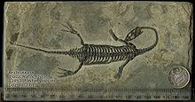](https://en.wikipedia.org/wiki/File:Keichousaurus_fossil_with_scale.jpg)

20cm fossil *Keichousaurus*

The locomotion of *Keichousaurus*probably resembled (in part) the "underwater flight" that [plesiosaurs](https://en.wikipedia.org/wiki/Plesiosaurs) employed. The flattened forelimbs would likely have acted as hydrofoils. The hindlimbs show less specialization, and may therefore have acted as stabilizers and control surfaces, such as is seen in extant sea turtles. The intermediate nature of the limb morphology implies that there was also, to some extent, the kind of 'crawling through the water' seen in small freshwater turtles. The powerfully built pectoral girdle allowed for the attachment of strong muscles, but their location beneath the shoulder favours the underwater flight model. Despite the specialization of the limbs, the tail also shows adaptations to an aquatic existence. Lateral transverse processes of the anterior caudal vertebrae show that powerful muscles enabled the tail to beat or at least undulate from side to side. This would imply some distal lateral compression, but this is not recorded in soft-tissue preservation. The long neck was primarily concerned with prey-capture. The combination of powerful limbs and tail would have made *K. hui* an adept and maneuverable predator.

Reproduction[[edit](https://en.wikipedia.org/w/index.php?title=Keichousaurus&action=edit&section=4)]

Although there is no direct evidence, *Keichosaurus* was potentially ovoviviparous (eggs form and hatch within uterus). Fossil *Keichousaurus*display a simplified elbow joint and a lack of ossification in the olecranon process of the ulna. This would make crawling up the beach to lay eggs awkward. Specimens at different developmental stages, found in the same type of sediment at the same locality, also support an ovoviviparous reproduction model. However, fossils have been found of female *Keichousaurus* with fetuses within the lower portion of the thoracic cavity. Their position implies that they are not victims of [cannibalism](https://en.wikipedia.org/wiki/Cannibalism).

References[[edit](https://en.wikipedia.org/w/index.php?title=Keichousaurus&action=edit&section=5)]

* 1. [**^**](https://en.wikipedia.org/wiki/Keichousaurus#cite_ref-1) [*"Keichousaurus"*](https://web.archive.org/web/20170421211223/go2add.com/paleo/Keichousaurus.php)*. Different Directions. Archived from*[*the original*](http://go2add.com/paleo/Keichousaurus.php)*on 2017-04-21. Retrieved 2018-04-13.*
* [*"keichousaurus"*](https://web.archive.org/web/20030516135855/http:/www.geocities.com/sea_saur/keichousaurus.html)*. Archived from*[*the original*](http://www.geocities.com/sea_saur/keichousaurus.html)*on 2003-05-16.*
* [peripstus.com/Keichousaurus](https://web.archive.org/web/20080429200032/http:/www.peripatus.gen.nz/Taxa/Chordata/Keichousaurus.html)
* [Functional morphology and ontogeny of Keichousaurus hui](https://www.biodiversitylibrary.org/item/25106)